WANDERING IN WOODS GAME

A PROJECT REPORT

*Submitted by*

Mani Ratnam Kasoju

Praveen Thumati

Vamshi Reddy Musku

Venkata Ramana Patnam

**Table of Contents**

1.0 Introduction 3

1.1 Purpose 3

1.3 Analyzing game requirements: 3

2.0 Model Selection 4

3.0 Use Cases 4

4.0 UML Model 6

4.1 Use case Diagram 6

4.2 Deployment Diagram 6

4.3 Class Diagram 6

4.4 State Diagram 7

4.5 Activity Diagram 7

5.0 Customer Journey Map 8

6.0 Personas 8

7.0 UI Mockup 8

8.0 Testing Strategy 9

8.1 Unit Testing 9

8.2 Integration Testing 9

8.3 Usability Testing 10

8.4 Validation Testing 10

User Manual: 10

References 19

# 1.0 Introduction

## 1.1 Purpose

Game development and simulation has occupied a great space these days. Mainly games that can be played in pairs. Through the advent of the internet and mobile devices, people have started to play games right from the young age. Games are being played by people from young age to people at old. This highest demand for games have stimulated us to the development of this wander woods game.  
  
**1.2 Specification**

Wandering in woods is one of the most interesting games and this game development is being performed using java. This game is developed by categorizing it into three levels. This game is pair-based game where a single player cannot play this game. Minimum of 2 players is essential for this game.

## 1.3 Analyzing game requirements:

Game is composed of three stages. Initially when the game is started, the game prompts the user to enter the level. Since the game is composed of only 3 levels, users can enter only 3 levels like level 1,level 2, level3. If any other levels are entered then the game considers it as invalid.

K-2

This is a dual player game and both players will be playing in boxes. Here the user is provided with an option select the size of the square grid. The game will proceed to continue until both players reach the same box in the square.

K 3-5

In this stage, the user will be provided with an option to select his grid size and the number of players but limited only to 5 based on his preference. One major change here is the grid which is changed from square to rectangle. This game also will continue and the number of times a player meets another player will also be recorded.

K 6-8

In this stage, maximum of players do participate in the game. Statistics of each player will be estimated and the estimated result will be proposed to user once the user meets with another player within the same box

Here, the players are moved from one position to another position. In this level, a player is selected and has to calculate the distance between each player. The distance covered by the player is the longest run without meeting each other, the shortest and average run without meeting each other. Hence, this is the main idea of the game Wandering in the Woods.

# 2.0 Model Selection

First software development model is selected to start the development of wandering in woods game. Among different models, water model is considered to be the best and more suitable method for this wandering in woods game. The Game development is done in a sequential way like after completing one stage of the game, the development process will reach the next stage.

Gathering essential ideas – Basic requirements like the number of stages, number of players in each stage and operations that needs to be done in each level is collected.

Analyzing the needs – System functionalities are analyzed.

Design - Performing initial design works like selection of how the game should look, players’ selection and other options.

Coding phase – Java programming language has been selected to develop the wandering game project.

Testing – The developed game is put through the testing phase so that defects in game can be identified and resolved at the earliest thereby making error free game. (Haraty, 2018).

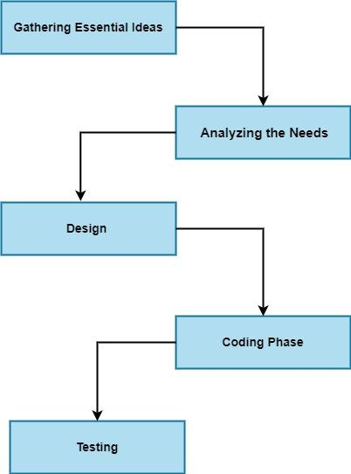

**3.0 Use Cases**   
  
The 3 use cases of the project are as follows.

**Use case 1: K-2 Grade**

Primary performer: Player

Initial Condition: Game build for two players

Details: With the created program Game simulation k-2 is executed. Rows and grids are entered manually, once the selection process is completed the game begins by selecting the ok button. Two different players are indicated with two different colour dots. Each played with will be different grids and once the player reaches the same grid the game comes to an end.

Acceptance level: two player game is played with the help of K-2 Simulation.

**Use case 2: 3-4 Grade**

Primary performer: Player

Initial conditions: Game build for three players

Details: The players have an option to select the starting position of the game and making the game to play will take more time on comparison with 2 player game as there are more selection steps in this use case. Once game gets completed the players can view the number views made by them and at which point the player came into contact will also be displayed

Acceptance level: player count >2 && player count <=5

**Use case 3: 6-8 Grade**

Primary performer: Player

Initial conditions: Game creation for a maximum of eight players.

Details: Once the program is executed the plays will get an opportunity to select the grade they wish to start. Selection of rows and columns and grids are performed by the players of the game. Each player’s steps and average steps in the gameplay will be displayed. Compared to use case 2, use case 3 will take longer time for the completion of game.

Acceptance Level: Player count >=6 && Player count ==8

# 4.0 UML Model

## 4.1 Use case Diagram

The use case diagram is typically developed in the early stage of development and people are often used to applying this use case model for purposes like the specification of the system context, requirements of the system captured, the architecture of the systems validated, generating test cases and drive implementation and it is developed by the analysts together with experts of the domain. A dynamic aspect of the system is portrayed by the use case diagram. The system requirement is accumulated which is included with internal and external influences. Use case diagram is used to invoke the person, cases, and many things which invokes elements and actors to bet implementation (Koc, 2021). It is used to represent how its entity is from an external environment that interacts with system parts. Once the program execution is performed the wander wood game begins. Depending upon the number of player’s number of the column and rows can be selected. Each player are differentiated by each colour. After selecting the requirement once the player are ready and click ok button, a welcome message gets displayed and players starts playing the game.

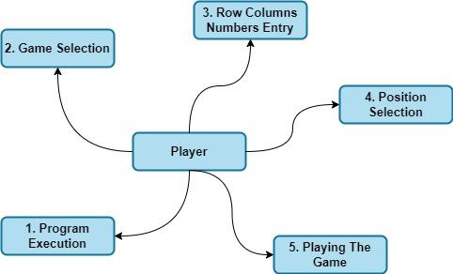

## 4.2 Deployment Diagram

The deployment diagram is used to visualize the physical hardware in which deployment is done in the software. It is used for portraying the static development view of the system. The main purpose of this deployment diagram is to represent how the software is installed in the hardware component. It is used to depict in what manner the software used to interact with the hardware that is used to perform its execution. It is a diagram that is used to show its run time processing nodes and its configuration and the live components on them. The physical aspects of the object-oriented system are modeled with the deployment diagram.

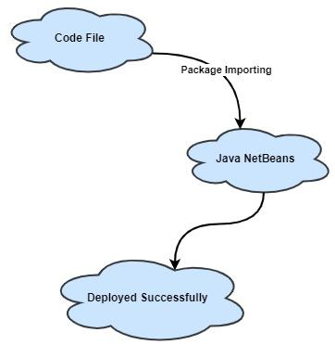

## 4.3 Class Diagram

The class diagram in the UML is known to be a type of static structure diagram used to describe the structure of the system in showing its classes, operations, attributes, and relationships within the objects. The main purpose of this class diagram is to show a static structure for the classifiers in the system, The diagram is used to provide a basic notation for the other diagram which is prescribed using UML; The class diagram is very helpful for the team members, and developers and the business analysts use the class diagrams for model the system based on business perspective.

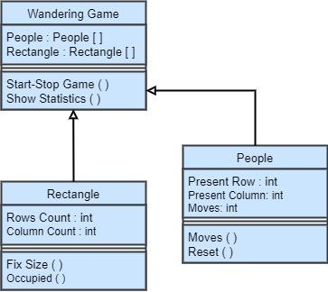

## 4.4 State Diagram

A state diagram is a diagram used to represent a system condition or the system part with a finite instance of the time. They are known as behavioral diagrams and they represent a behavior that uses finite state transitions. The state diagrams are also referred to be state chart diagrams or state machines. This state diagram is a model with a dynamic behavior in the class in which it responds to changing external stimuli. The events are stated using it which is responsible for the change in the state. It uses a model that has a system with a dynamic behavior.

## 4.5 Activity Diagram

An activity diagram is an important diagram in UML which used to describe a system's dynamic aspects. This activity diagram is essential in an advanced version of the flow chart which models a flow from one activity to another activity. The activity diagrams help in describing how the activities are coordinated in providing a service that used to be in different levels for an abstraction (Nikiforova, 2011). The events have a need that used to be achieved using some of the operations that are particular in where an operation has been intended in achieving several different things which require coordination.

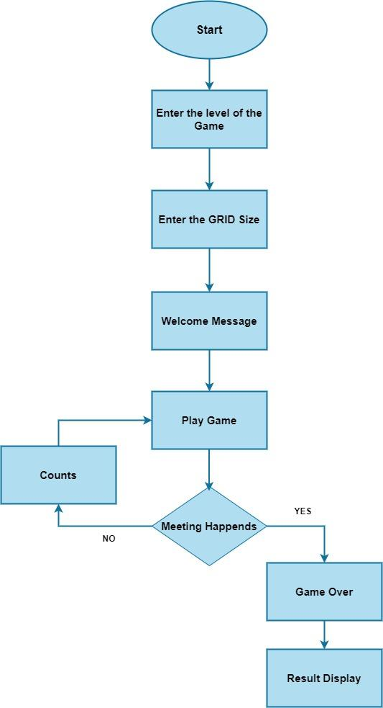

# 5.0 Customer Journey Map

A customer journey map is defined to be a visual representation of a customer’s journey and it helps in telling the story from the experiences of the customers with a brand that is across its touchpoints. When the customer interacts the social media, live chat, emails, or any other channels it maps the customer journey visually and then helps out in ensuring that no customer can slip through the cracks. Customer journey mapping has a process for creating a customer journey map which is a visual story for the interaction of customers in the brand (Rosenbaum, 2016). This is an exercise that helps businesses step into the shoes of the customers and look at business from the perspective of customers.

# 6.0 Personas

The main purpose of this persona is to create reliable and realistic representations for the reference of key audience segments. The representation has to be based on quantitative and qualitative research and web analytics. The personas are very effective when they are used to represent a user group on a website. It expresses and focuses on the major expectations and needs of the important group of users. A clear picture is given based on the expectations of the users and they are likely to use the site. It uncovers a universal functionality and features. The personas help in focusing their decisions to be surrounded with components in the site by adding layers in the real world with a conversation for the considerations.

# 7.0 UI Mockup

UI Mockup is a visual representation that is designed for a final digital website or a product which includes icons, color, layout, and other UI elements. The mockups are high-fidelity designs which are static and they do not have any functionality. The mockup is a crucial part of the design thinking process since it answers important visual questions and allows the designers to start with high fidelity prototype. The Mockup used to have meaningful stakeholder feedback, a realistic perspective, and flexibility (Rivero, 2010). The mockup is mainly used to follow the paper prototype and wireframes for the design process and the designers design the UI kit to follow handwritten notes in building the mock-ups.

# 8.0 Testing Strategy

The testing strategy is a document used for gathering and organizing the test cases using the functional areas or the testing types that come in a format to be presented in a team. The important thing to be defined in the testing strategy is they are very accurate in creating the test cases and are also used to manage the timeline of the project and make the testing to be performed using the critical deadlines. There are various phases in a test strategy to be crafted with a selected software development lifecycle model for a team.

The approach of the testing strategy is described with a software team which is used to ensure the delivered software meets its quality standards and requirements by the boundary set by clients. There are four test case categories selected by the development team and they are unit testing, integration testing, usability testing, and validation testing.

## 8.1 Unit Testing

Unit testing is a software development process in which it has the smallest testable part for an application known to be units and they are scrutinized individually with proper operations. Unit testing is used to test individual units of the software components that are used to ensure an intended function. There is a main objective for unit testing which is isolated in a written code for testing and determining if the works are intended. For the process of development, unit testing is a very important step. If the unit testing is done correctly then this unit test is used to detect early flaws in a code that used to be difficult in finding the later testing stages.

## 8.2 Integration Testing

Integration testing is a level two testing for software testing and they are used to check the individual components in exposing problems and defects to verify if the work is designed together (Sawant, 2012). Integration testing is used to test the integration of the software with different components which ensures the system to be worked together. It is used to ensure correctly integrated module functions. The interface errors were uncovered in this testing and the integration testing was used to provide testers in the analysis of the system which dramatically reduced severe connectivity issues. A detailed interface verification is created in designing test cases.

## 8.3 Usability Testing

Usability testing refers to the evaluation of the service or product using testing used for representative users. At the time of testing, the participants have to complete their typical tasks which are to observe and watch, take, and listen to notes. The main goal is to identify any usability problems and they are used to collect quantitative and qualitative data and determine the satisfaction of the product participants. The usability testing has designed and development teams that are used to identify the problems which has been coded and it has issues for the fixed and identified ways which is less expensive in the staff time and impact of the schedule.

## 8.4 Validation Testing

Validation testing is a process that is used to assess a new software product which is used to ensure the performance of the matches that are needed for customers. The product development team used to perform validation testing to learn about the integrity of the product and its performance in a different environment. The developers used to perform the validation testing or they can collaborate with the professionals of quality assurance, external validation testing clients, or professionals who used to identify the elements with a code to improve. The developers combine the testing types with the other techniques which help in ensuring a product is ready for the market.

**User Manual:**User manual is one the essential document which will be very useful for the end user to understand about the functioning of the game. This manual will have detailed documentation of complete game functionalities and how to run the game.

Java Netbeans IDE is used here. The code can be imported by selecting the coding files located in the system. Then the main method is selected to run the code.

Process 1: Run WanderingGame.java. Initial input image will be displayed. Here the player provides a number.

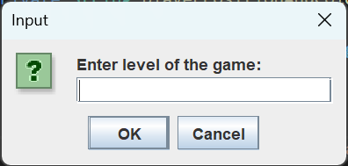

If the player enters a number that is either greater than 3 or less than 1 then program will show the below error message.

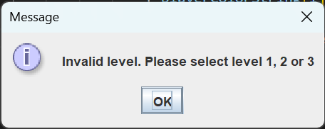

When the player provides 1 then the k2 game will be played.

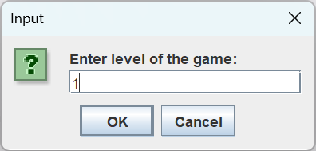

The information about the k-2 level like shape of the grid, players position will be projected on the players screen.

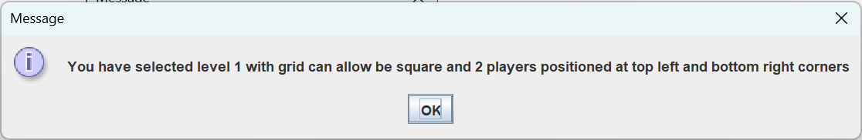

Enter grid size. In terms of level one only grid size will be asked instead of row and column individually

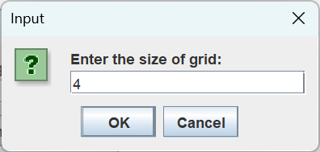

Game info before starting the game will be made to be seen for the player.

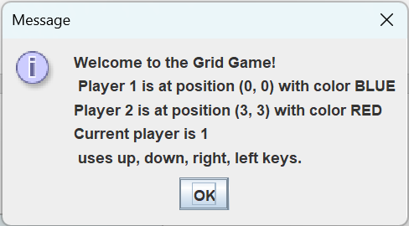  
The gaming window will be displayed as shown below

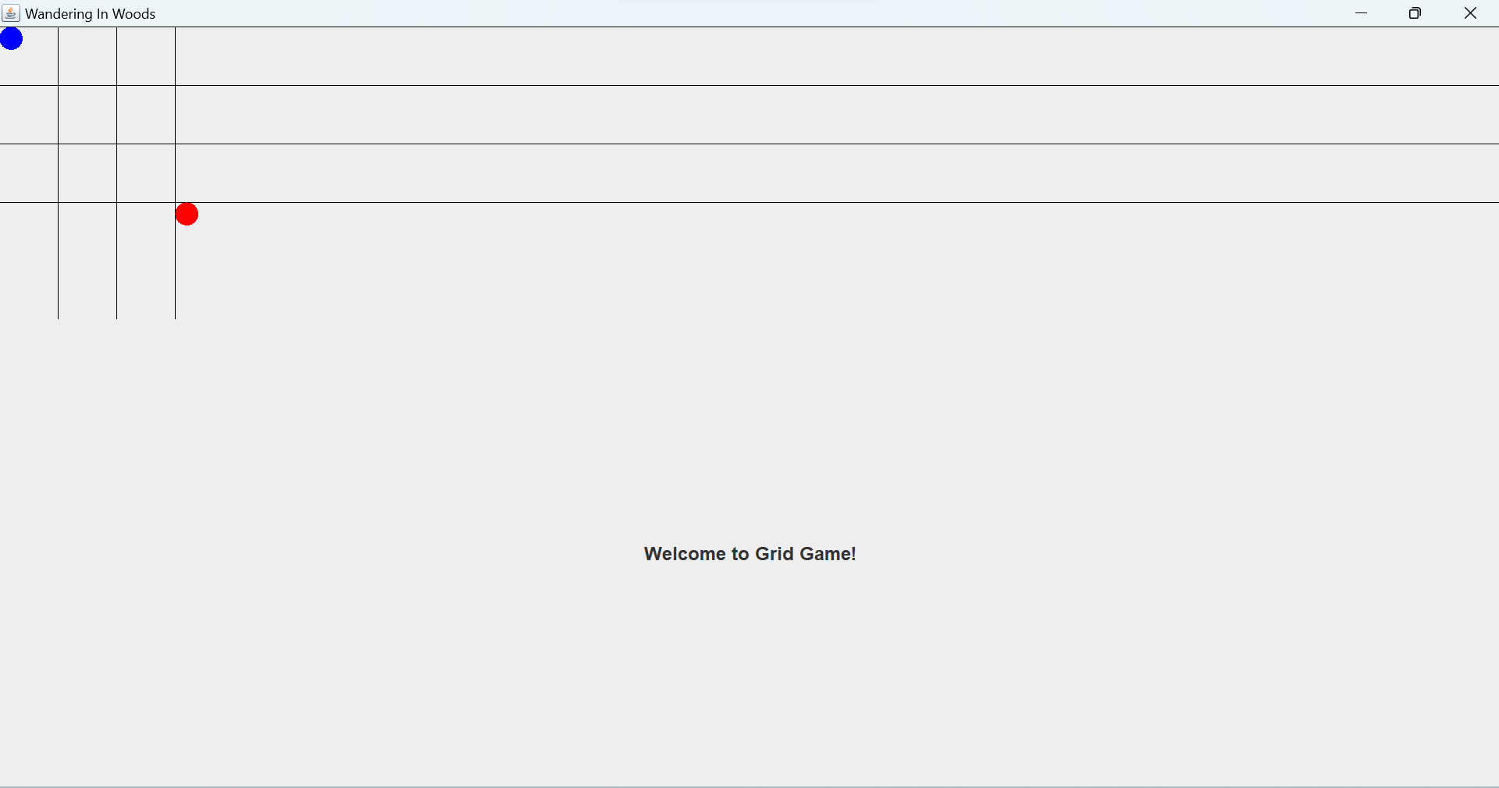

Players can use arrow keys to move the player in the game.

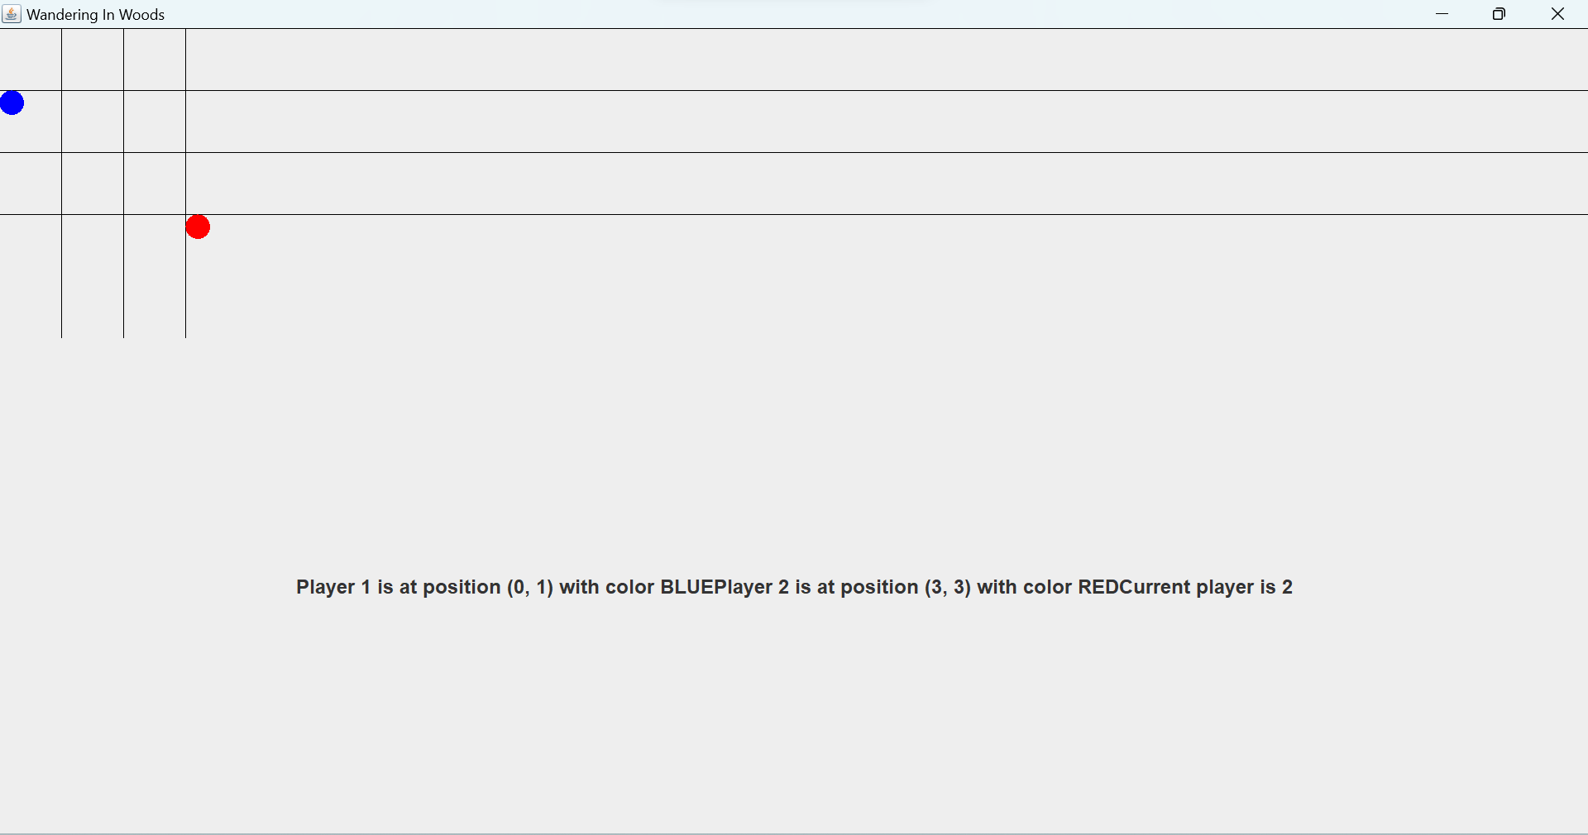

Once both players meets then the below video will be playing with a background noise.

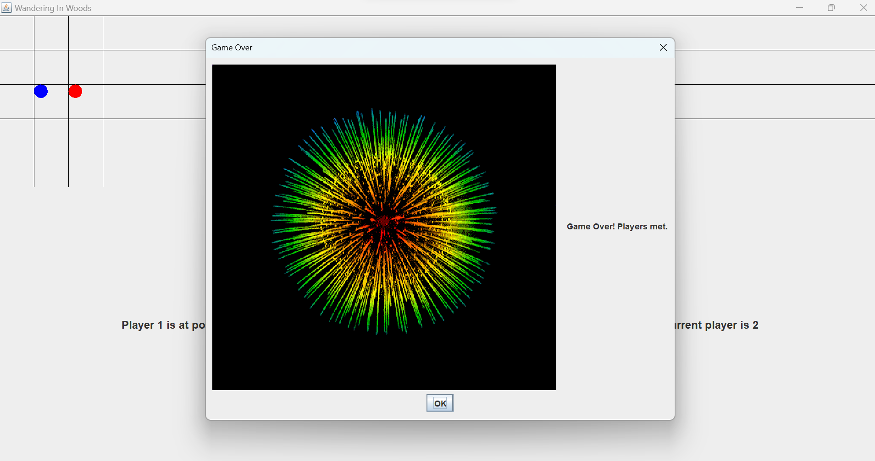

Game will reset automatically once the game is over and the game will start again.



Stage 2:

Conditions:  
grid – rectangle  
player count – 2 to 5  
Options – prompts users to enter the rows, columns, position of each player.

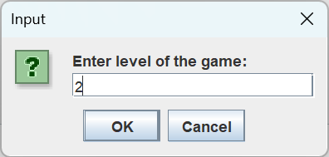

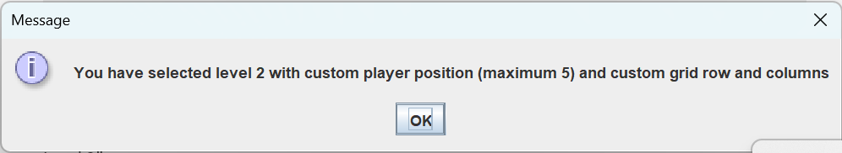

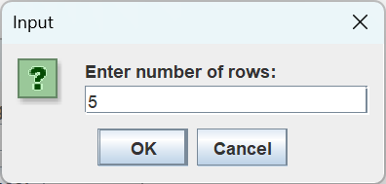

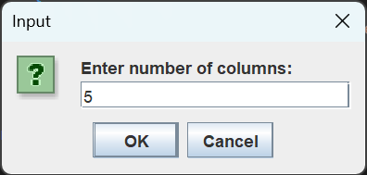

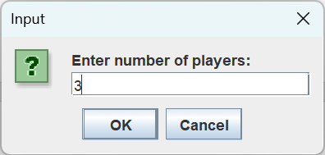

Positioning of each player is performed here.

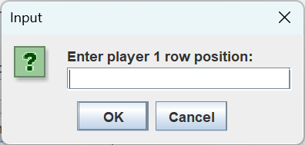

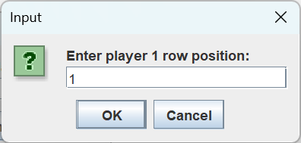

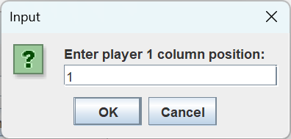

If a wrong position which is the position not in the rectangular grid is entered then this should be considered as exception and exception message will be displayed.

Before the start of the game, exact location of all the players will be shown on the screen.

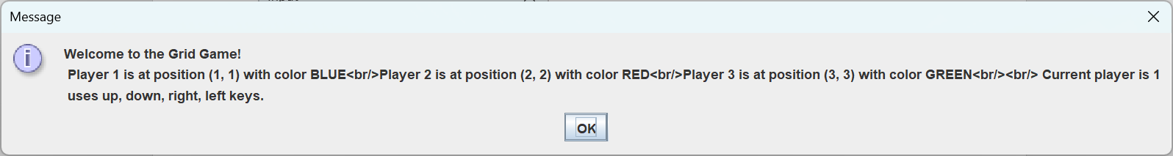

Initial screen of K 3-5 condition game screen is pictured below.

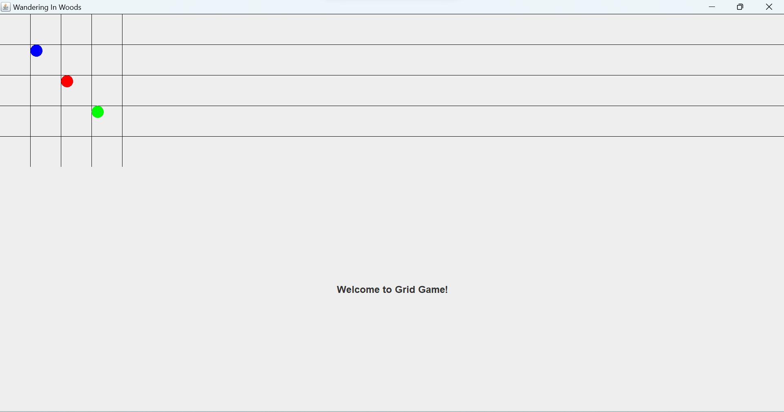

Proposing the current location of players in grid prior to the start of the game.

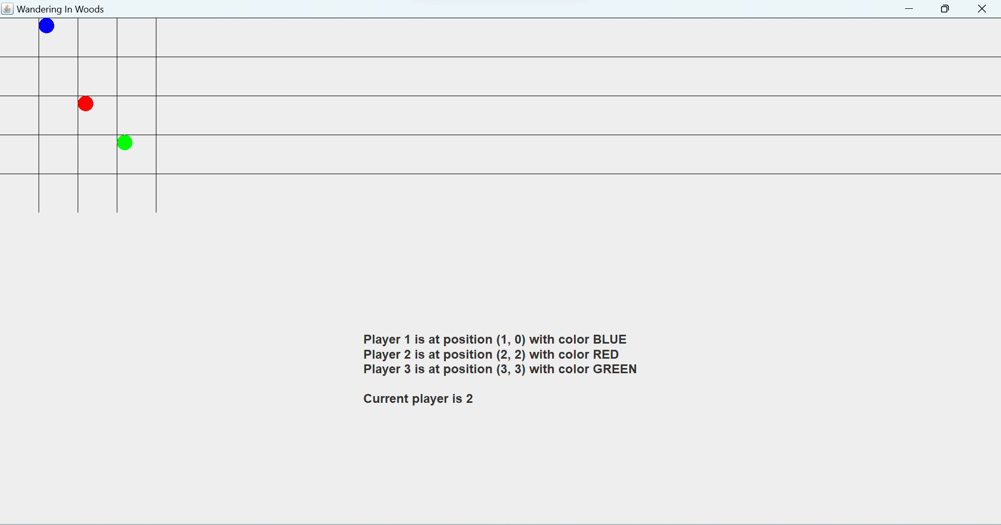

Displays number of meetings happened for each player.

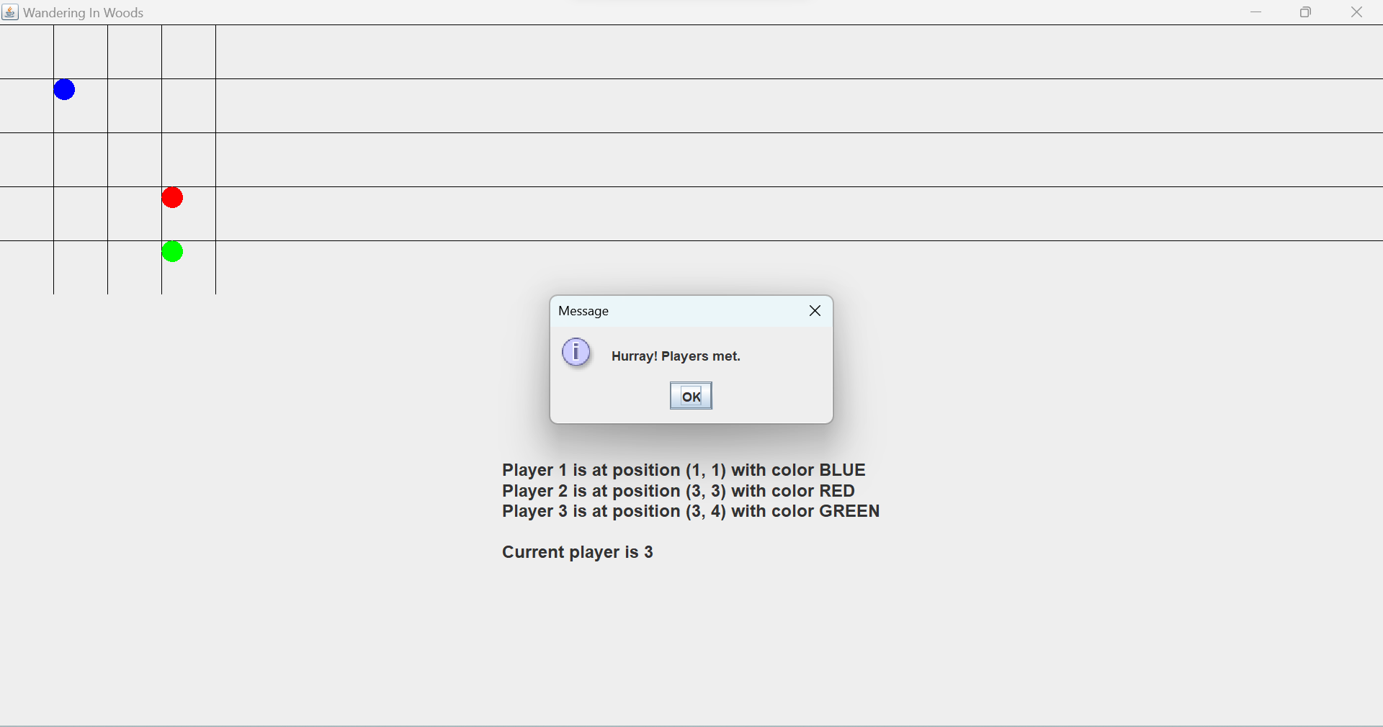

Here we show player 3 met 1 player. Since we added points to player who met and not the person who has been met

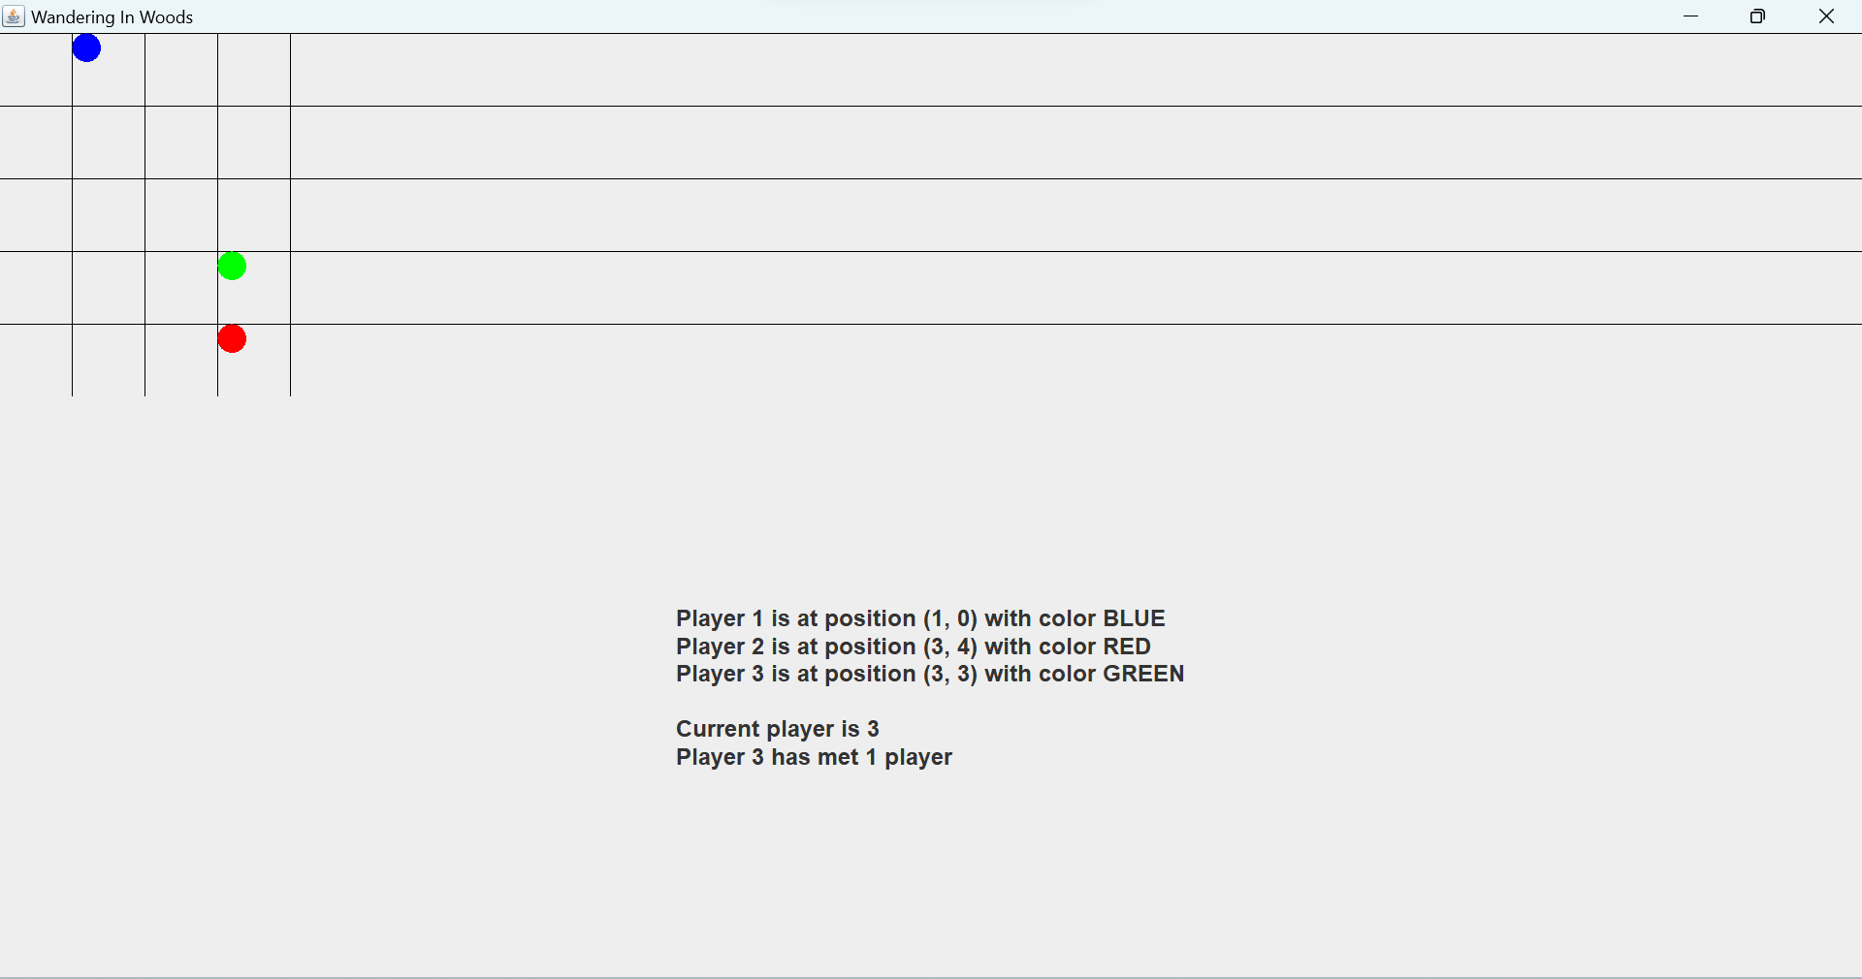

Level 3

This stage follows the same steps performed in stage 2 but here the maximum player count is limited to 8.

Message details of final level K-8

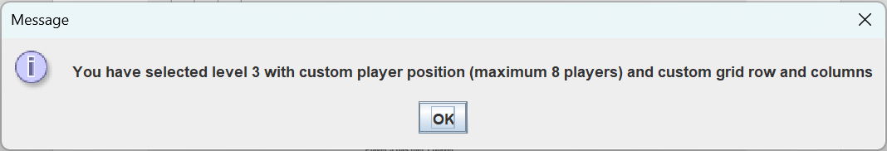

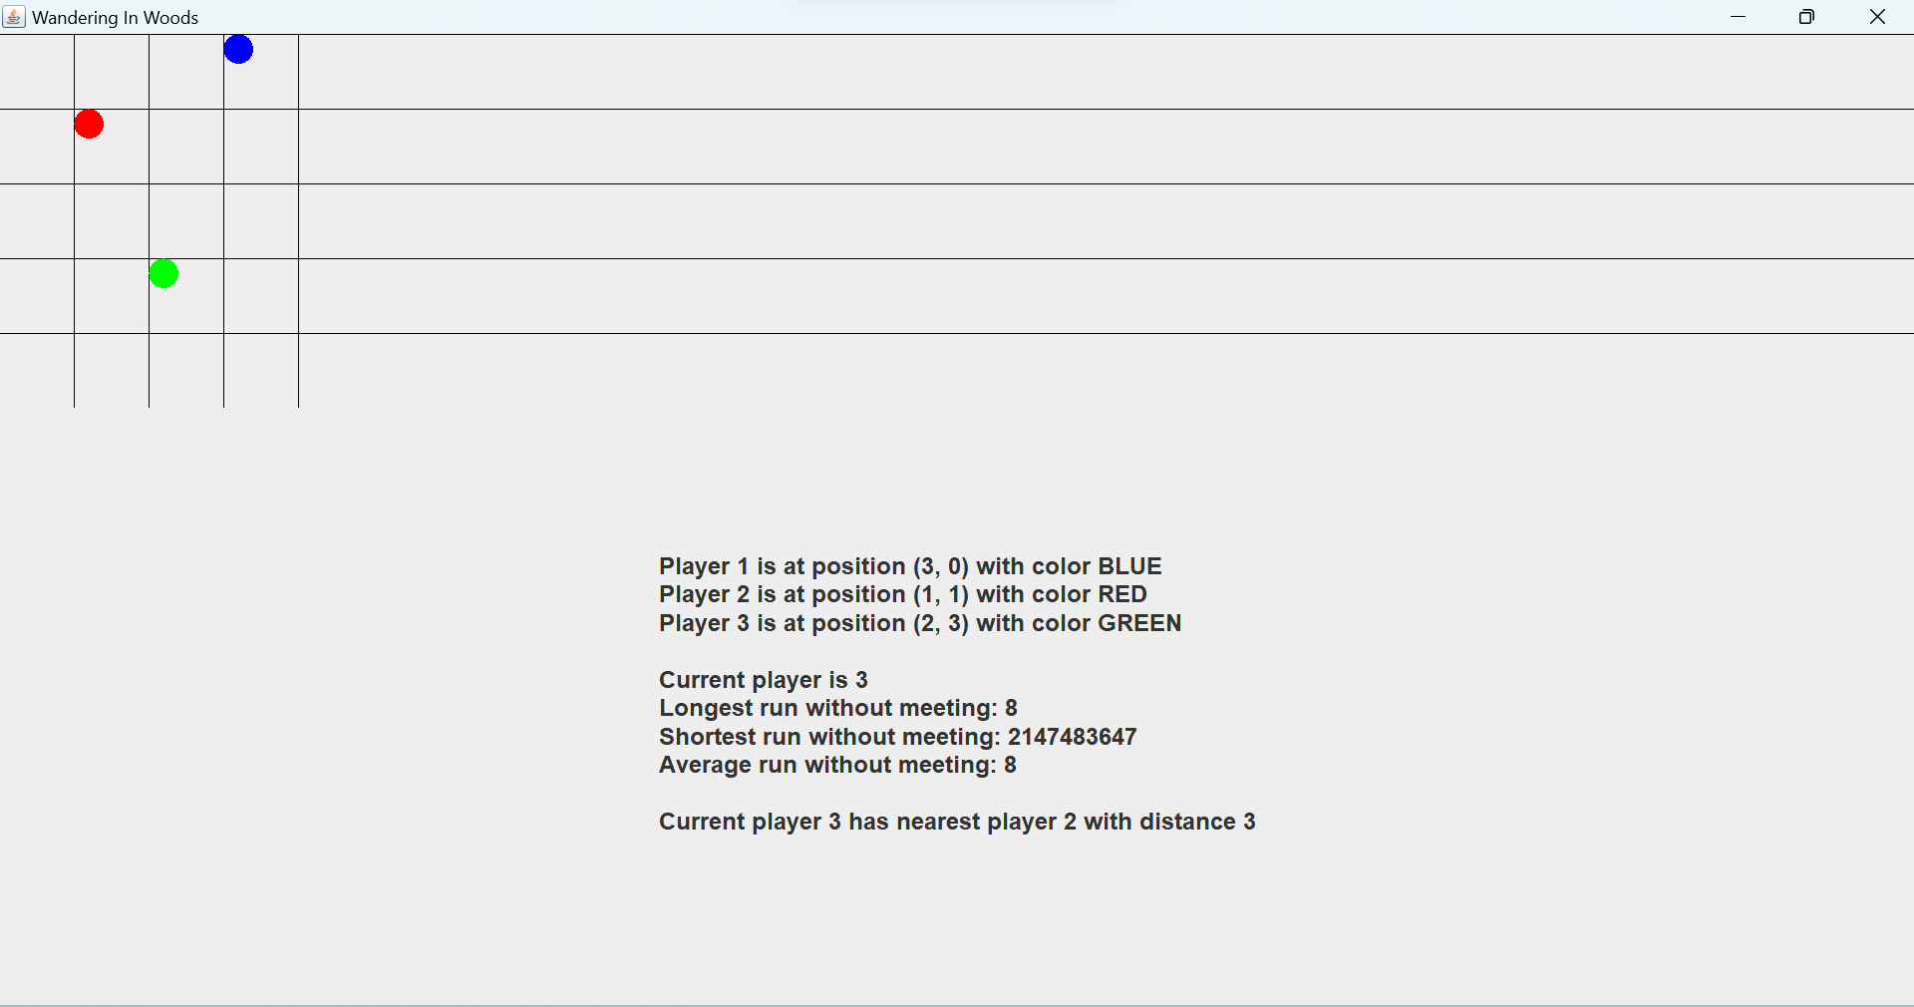

Game functionalities are same as previous level.

# References

Chiorri, C. (2023). The Role of Mindfulness, Mind Wandering, Attentional Control, and Maladaptive Personality Traits in Problematic Gaming Behavior. *Mindfulness* , 648-670.

Haraty, R. A. (2018). Software process models: A review and analysis. *International Journal of Engineering & Technology*, 325-331.

Koc, H. (2021). UML Diagrams in Software Engineering Research: A Systematic Literature Review. *Proceedings* , 1-10.

Nikiforova, O. (2011). Role of UML Class Diagram in Object-Oriented Software Development. *Scientific Journal of Riga Technical University Computer Sciences*, 65-74.

Rivero, J. M. (2010). From Mockups to User Interface Models: An Extensible Model Driven Approach. *Conference: Current Trends in Web Engineering - 10th International Conference on Web Engineering, ICWE 2010 Workshops, Vienna, Austria, July 2010, Revised Selected Papers*, 12-25.

Rosenbaum, M. S. (2016). How to create a realistic customer journey map. *Business Horizons*, 1-19.

Sawant, A. A. (2012). Software Testing Techniques and Strategies. *International Journal of Engineering Research and Applications*, 980-986.